**[20] Design Turing Machine For Substraction W = AAA – AA**

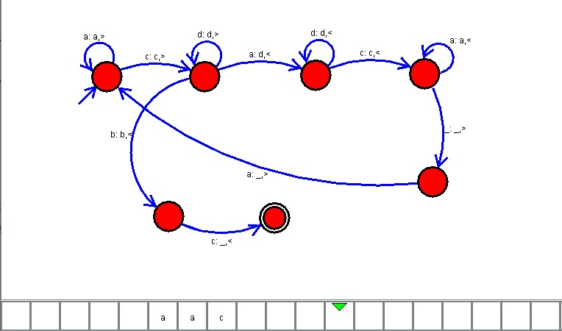

**Result**

The TM is designed to perform the subtraction with given strings as input using AutoSim tool